**EXPERIMENT-9**

**AIM :** Write SQL queries to perform KEY CONSTRAINTS (i.e. PRIMARY KEY, FOREIGN KEY,UNIQUE NOT NULL, CHECK, DEFAULT).

**Types of SQL Constraints.**

1. NOT NULL - Ensures that a column cannot have a NULL value
2. UNIQUE - Ensures that all values in a column are different
3. PRIMARY KEY - A combination of a NOT NULL and UNIQUE. Uniquely I identifies each row in a table
4. FOREIGN KEY - Uniquely identifies a row/record in another table
5. CHECK - Ensures that all values in a column satisfies a specific condition
6. DEFAULT - Sets a default value for a column when no value is specified

1.NOT NULL Constraint Example:

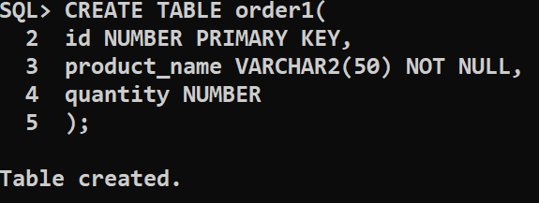

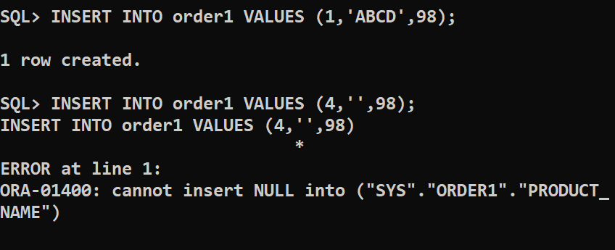

2.UNIQUE CONSTRAINT:

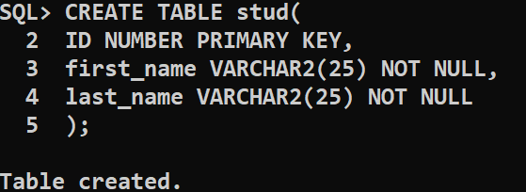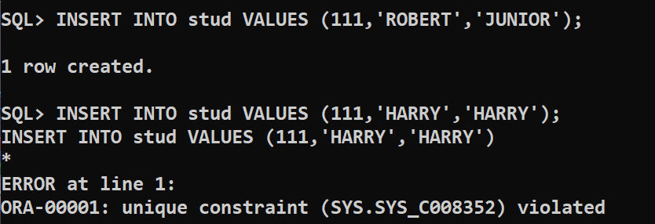

3.PRIMARY KEY CONSTRAINT : 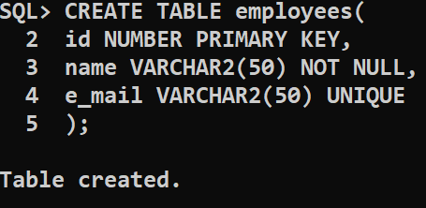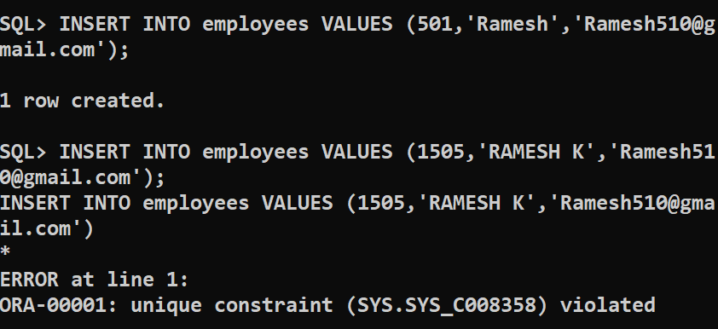

4.FORIEGN KEY CONSTRAINTS: 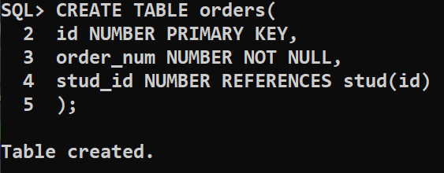

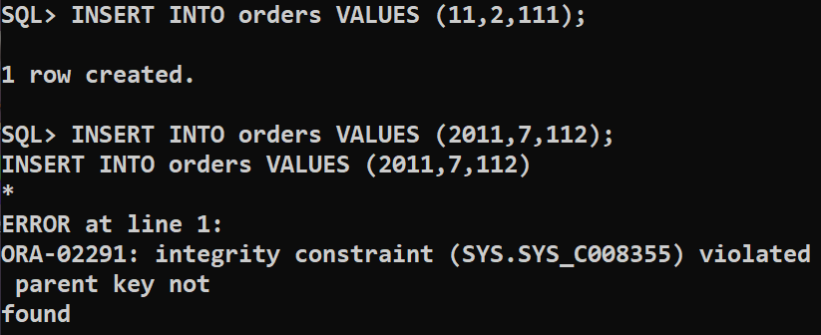

5.CHECK CONSTRAINTS:

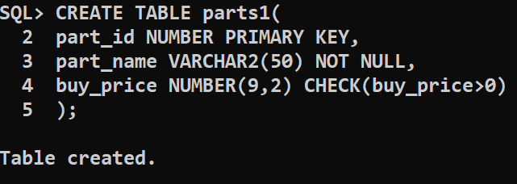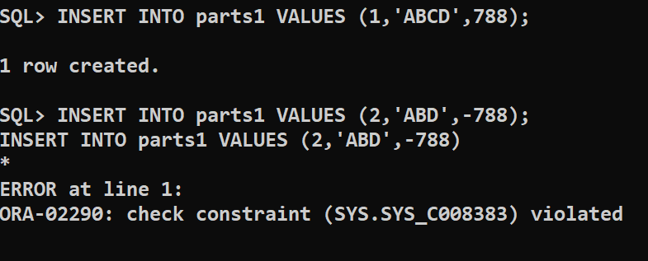

6.DEFAULT CONSTRAINTS: 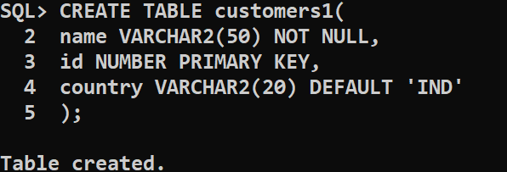

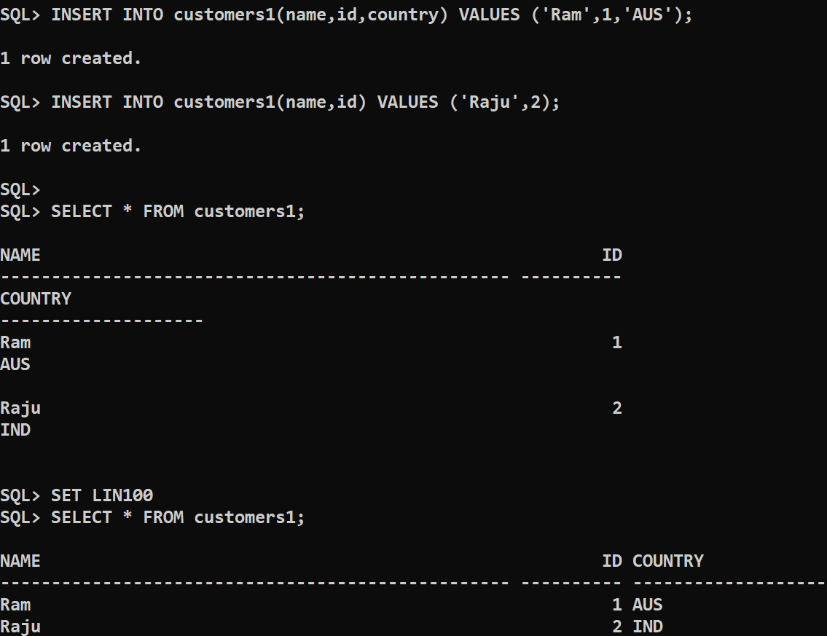

CONCLUSION : The sql queries to perform key constraints are

successfully executed.